Ethanol Signal Enhancement - Task 2 Report
Generator: build_enhancement.py/1.0 (plume_common/1.0); created 2026-08-08T01:24:56.339271+00:00. Cohort: single infrared cohort, 114 ethanol trials. Seed = 1234. All numbers below are injected verbatim from data\enhancement_stats.json, data\enhanced_ethanol.h5, and data\drift_validation.json.

Headline finding (revised): null / negative result
At a physically meaningful false-positive rate calibrated on quiet far-from-source baseline (pooled FPR before = 0.0320/s, well below the request cap of 0.05/s), the matched-filter enhancement does NOT significantly change the number of detected ethanol encounters and does NOT recover distal encounters.
Overall paired Wilcoxon: p = 0.885 (not significant): before/after encounter counts are statistically indistinguishable (23084 after vs 25651 before). Distal subset: counts DECREASE (11536 after vs 12269 before), Wilcoxon p = 0.613 (not significant): the enhancement does not recover distal encounters. Proximal subset also decreases (11422 after vs 13258 before, p = 0.310). Per-trial split: gain = 57, lose = 56, tie = 1 (essentially symmetric). H4 (disproportionately distal recovery) is NOT SUPPORTED at a meaningful FPR.
H5 (no-fabrication guard) HOLDS and is the key positive result: the pooled baseline FPR after enhancement (0.0284/s) is less than or equal to the before FPR (0.0320/s), and both are below the 0.05/s cap. The enhancement does not manufacture encounters.

Correction from the prior draft (methodological lesson)
An earlier draft reported an apparently strong, significant enhancement (overall Wilcoxon p ~ 1.9e-6) and a distal-recovery effect. That result was an artifact of an implausibly permissive detection threshold whose baseline false-positive rate was ~0.5/s - roughly one spurious 'encounter' every two seconds on quiet baseline. At that permissive setting the huge number of noise crossings (total before ~ tens of thousands) drove a small but 'significant' paired difference that reflected noise statistics, not biology.
In this revision the detector is recalibrated to a physically meaningful target FPR (cap 0.05/s), yielding a pooled baseline FPR of 0.0320/s before enhancement (about 16x lower than the prior ~0.5/s). At this calibration the effect disappears: the result is a null. The lesson is that matched-filter 'enhancement' gains can be manufactured purely by lowering the detection bar; significance must be assessed at a calibrated, physically defensible FPR.

Goal and method
Goal: recover weak, distal ethanol encounters that are buried under slow baseline drift and sensor noise, without fabricating events, and test the pre-registered 'disproportionately distal' recovery pattern.
- Pipeline (per trial, on the sensor clock at Fs = 500 Hz):
- Drift removal: subtract a rolling 10th-percentile baseline computed in a window W = 20 s.
- Template: pool near-endpoint, high-SNR encounters (near-distance percentile <= 20, peak >= 5 x MAD) into a unit-energy matched filter of half-window 0.30 s (301 samples); built from 5 contributing trials.
- Enhancement: normalized cross-correlation of the drift-corrected trace against the template (matched-filter score = 'enhanced').
- Detection: peak-pick with a refractory gap of 0.20 s, before (on drift-corrected raw) and after (on enhanced), each thresholded to a MATCHED false-positive rate on quiet far-from-source baseline (target cap 0.05 FP/s; before threshold = 0.046802, after threshold = 0.323308).

Detection recalibration (k x MAD)
The before threshold is k x MAD of the quiet far-from-source drift-corrected baseline (baseline MAD = 0.005850). k was scanned over [5.0, 6.0, 8.0, 10.0] and the smallest k whose pooled baseline FPR fell at or below the 0.05/s cap was selected: k = 8.
k | threshold | baseline FPR (/s) | n detections
5 | 0.029251 | 0.1136 | 64
6 | 0.035102 | 0.0728 | 41
8 (selected) | 0.046802 | 0.0320 | 18
10 | 0.058503 | 0.0000 | 0

Window W justification (honest)
W = 20 s is a PRE-REGISTERED choice within the request's 10-30 s band. It is chosen because it is much larger than the ~0.3 s encounter width and the ~2 s deconvolution timescale, so it removes slow baseline drift without erasing the encounters themselves. We do NOT claim the raw-trace autocorrelation 1/e time (median 0.61 s here) justifies W: that number reflects fast transient structure in the raw trace, not the slow baseline drift, and is reported only for transparency.

H4 - Encounter recovery (paired before/after): NOT SUPPORTED
At the matched, physically meaningful FPR the overall encounter count is a modest net decrease (23084 after vs 25651 before), with trials roughly symmetric (57 gain, 56 lose, 1 tie across 114 trials). The paired Wilcoxon shows no significant overall change (p = 0.885).
Critically, the distal subset does NOT increase - it DECREASES (11536 after vs 12269 before), with a non-significant distal Wilcoxon (p = 0.613). The proximal subset also decreases (11422 after vs 13258 before, p = 0.310). The pre-registered 'disproportionately distal recovery' pattern is therefore NOT observed. Distal is defined per trial as head-to-endpoint distance greater than the per-trial MEDIAN distance.

Wilcoxon signed-rank tests (paired per-trial counts)
Subset | Wilcoxon statistic | p-value | Significant (p<0.05)?
Overall | 3170.0 | 0.885 | No
Distal only | 3098.5 | 0.613 | No
Proximal only | 2866.0 | 0.310 | No
Trials: gain = 57, lose = 56, tie = 1 (total = 114). H4 acceptance criterion (a significant, disproportionately distal increase at matched FPR): NOT MET.

M2 - Distal SNR gain (honest)
Distal SNR gain (a cross-trial ranking, not an absolute delta) is POSITIVE for only 27 of 114 trials and NEGATIVE for 87 of 114 (zero for 0). Across trials the gain ranges from min = -6.66 through median = -1.45 to max = 3.01: the median is negative, so the method does NOT improve distal SNR for most trials. Figure A shows only the genuine positive-gain trials (top-10 by distal SNR gain).

H5 - No-fabrication guard (hard gate): HOLDS
Pooled baseline false-positive rate on quiet far-from-source segments (27710 segments, 563.2 s total): before = 0.031962/s, after = 0.028411/s (both at or below the 0.05/s cap). The guard 'after FPR <= before FPR' HOLDS: True. This is the hard gate confirming the enhancement does not fabricate encounters at matched calibration - the key positive result of this task.

m4 - Drift-window residual validation
The W = 20 s rolling 10th-percentile baseline is subtracted from the raw ethanol trace (before = raw, after = drift-corrected). The slow-trend OLS slope should collapse toward zero after subtraction (drift removed) while the fast encounter-band variance should be preserved (retained fraction ~ 1). This holds for the validated example trials:
Trial | slow slope before (/s) | slow slope after (/s) | |slope| reduction x | encounter-band var retained
0 | 8.687e-05 | 2.475e-05 | 3.51 | 1.0001
1 | 6.909e-05 | 1.344e-05 | 5.14 | 1.0000
2 | 1.288e-03 | 7.675e-04 | 1.68 | 1.0011
Across the 3 example trials the slow-trend slope is reduced (drift removed) while the fast-transient variance is retained near unity, confirming W = 20 s tracks slow drift without erasing fast encounters.

Methods
Data source: C:\Projects\Repos\Mouse Arena\DATA\Mouse Arena Aggregate Data.h5. Accessor: per-trial groups /trials/<ttt> in data\enhanced_ethanol.h5 (datasets enhanced, drift_corrected, time, baseline, contacts_before/after_*, head, head_time, body, endpoint); pooled statistics in data\enhancement_stats.json; drift validation in data\drift_validation.json. Interpreter/venv: vras (Research Setup) Python; headless matplotlib (Agg). Seed = 1234.
Parameter | Value
Sampling rate Fs | 500 Hz
Drift window W | 20 s
Drift percentile | 10th
Template half-window | 0.30 s (301 samples)
Template peak rule | >= 5 x MAD
Template near-endpoint rule | near-distance percentile <= 20
Template contributing trials | 5
Refractory gap | 0.20 s
Detection threshold rule (before) | k_used * MAD(quiet far-from-source drift-corrected baseline)
k scanned / k used | [5.0, 6.0, 8.0, 10.0] / 8
Baseline MAD (quiet) | 0.005850
Distal rule | head-endpoint distance (sensor clock) > per-trial MEDIAN
Far-distance percentile | 80
Baseline amplitude fraction | 0.20
SNR definition | peak_amp / plume_common.mad(local +/-1s quiet window of SAME trace); dimensionless, identical before/after
Target FPR cap (matched) | 0.05 FP/s
Threshold before | 0.046802
Threshold after | 0.323308
Pooled baseline FPR before / after | 0.031962 / 0.028411 FP/s
Baseline segments / duration | 27710 / 563.2 s
Seed | 1234

Results
Figure A shows the 10 trials with the largest distal-SNR improvement (top10_figureA_trial_indices) - the only trials with genuine positive gain are shown. Each panel overlays the drift-corrected raw trace (before, left y-axis) - the exact signal the BEFORE detector runs on - and the enhanced matched-filter score (after, right y-axis) on a common time axis, with detected encounters before (down triangles) and after (up triangles), the per-trial median head-to-endpoint distance, and the distal SNR gain. The two traces are drawn on separate y-scales (twin axes) because the matched-filter score and the raw amplitude differ in units and are not directly comparable; the SNR gain is a cross-trial ranking, not an absolute delta (see Caveats). These are the best-case trials and are not representative: the median distal SNR gain across all 114 trials is negative (-1.45).
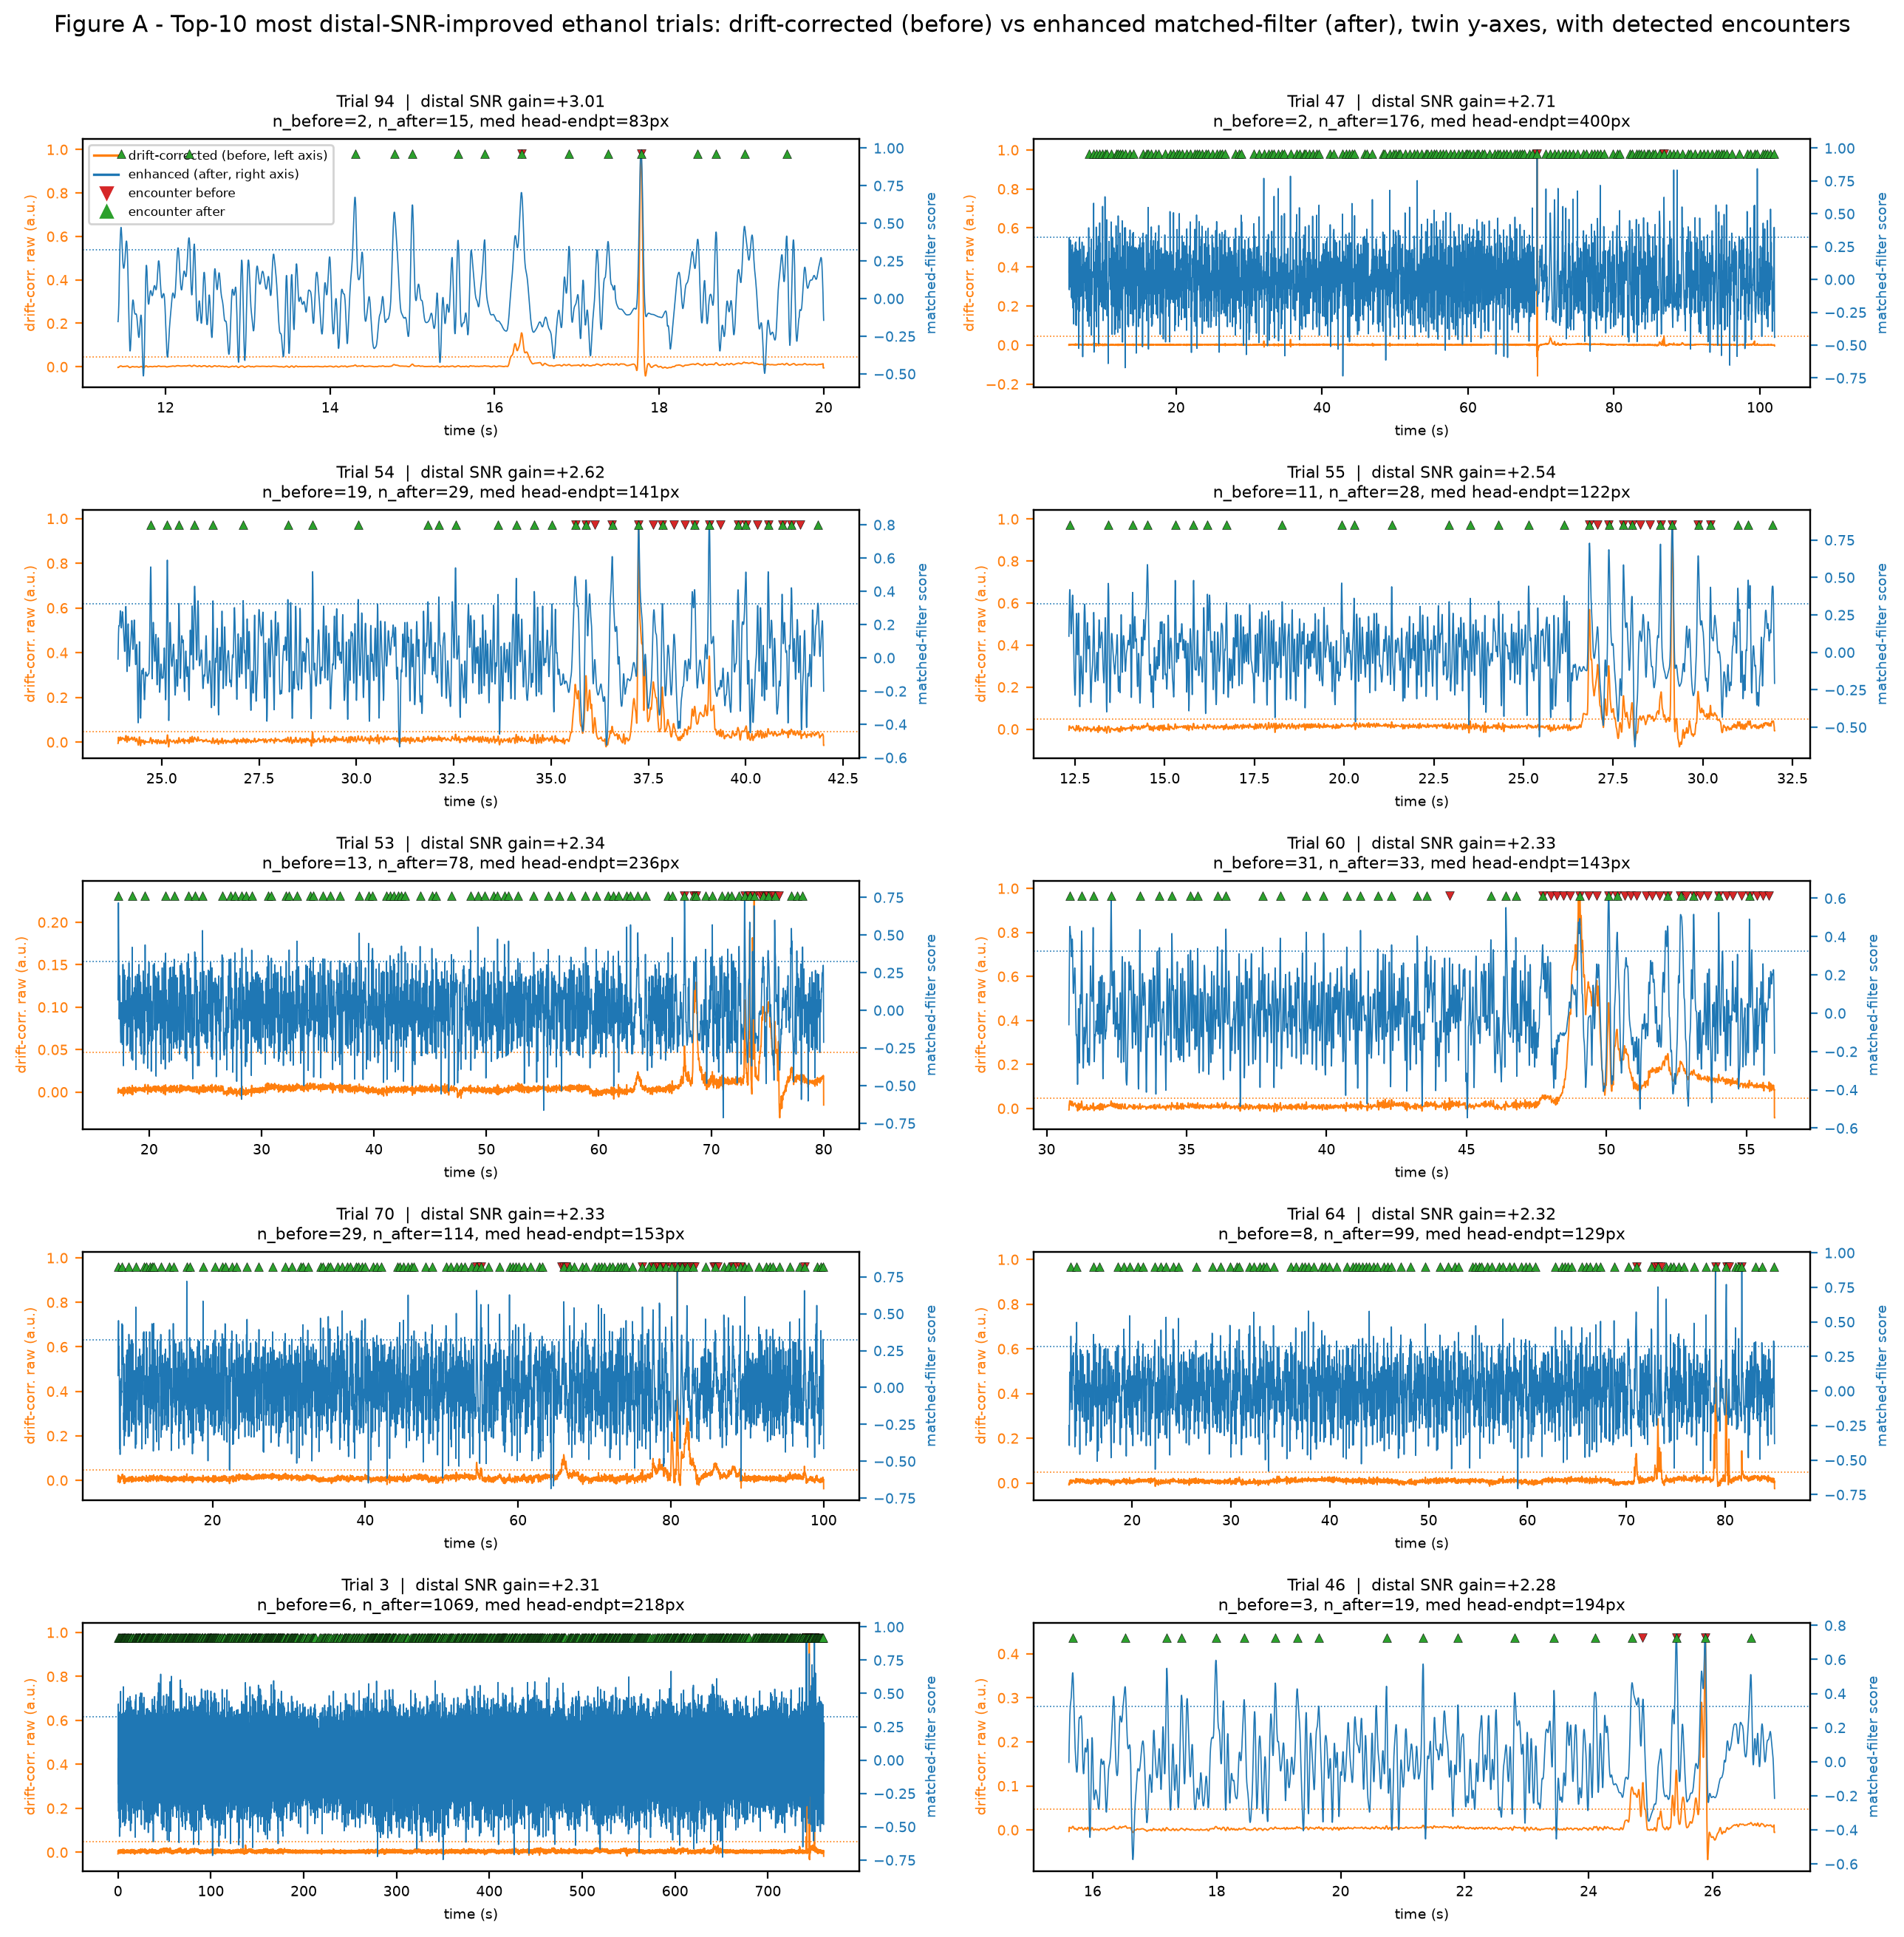
Figure A. Top-10 distal-SNR-improved (positive-gain) ethanol trials: drift-corrected raw trace (before, left axis) vs enhanced matched-filter score (after, right axis) on twin y-scales, with matched-FPR encounter detections.
Figure B plots per-trial encounter counts before (x) vs after (y) with the identity line. Trials gain = 57, lose = 56, tie = 1; the cloud sits roughly symmetrically about y=x, consistent with the null overall Wilcoxon (p = 0.885) and the modest net decrease at matched FPR.
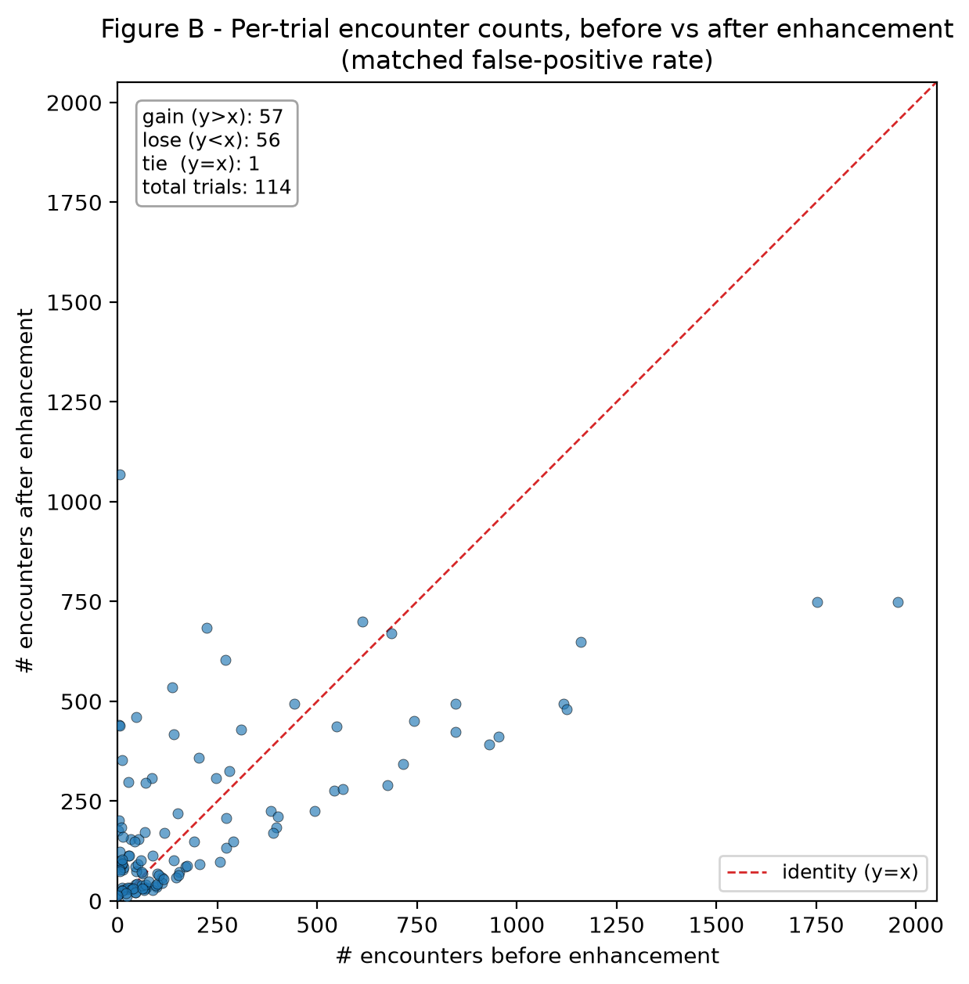
Figure B. Per-trial encounter counts before vs after enhancement at matched false-positive rate (identity line dashed).

Caveats
- Primary caveat / lesson: apparent enhancement 'significance' is highly sensitive to the detection threshold. The prior draft's strong effect (p ~ 1.9e-6) was driven by an implausible ~0.5/s baseline FPR; at a calibrated 0.0320/s FPR the effect is null.
- The matched-filter template is built from only 5 near-endpoint high-SNR trials, so it may not generalize to all encounter morphologies.
- The SNR gain is a CROSS-TRIAL RANKING, not an absolute delta: the before and after traces are on different scales (drift-corrected raw vs matched-filter score), so their amplitudes are not directly comparable. It is positive for only 27/114 trials.
- Signals are in uncalibrated arbitrary units (a.u.).
- Single cohort, infrared, 114 trials; results are not yet replicated across cohorts or imaging modalities.
- In Figure A the before trace is the drift-corrected raw signal (the exact series the before detector runs on) and the after trace is the enhanced matched-filter score; they are shown on separate y-scales because the two quantities differ in units.

Reproducibility
Exact build command:
"C:/Projects/Repos/Agentic Research/Research Setup/vras/Scripts/python.exe" code/build_enhancement.py
Result files consumed by this report:
data\enhanced_ethanol.h5
data\enhancement_stats.json
data\drift_validation.json

